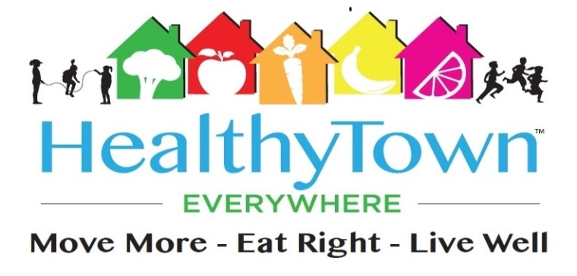
Press Release
9/29/2018
Paul Ehrmann , D.O.
248-563-0386
ehrmann.paul@gmail.com
HEALTHYTOWN EVERYWHERE AND ROYAL OAK MICHIGAN CHILDREN’S PROGRAM
OCTOBER 4TH THURSDAY, 2018
This event is scheduled to take place in Royal Oak Michigan with participation by the fifth graders of the Keller Elementary school, parents and educators.
Preceded by a warm up by the South Oakland YMCA of Royal Oak, we will be embarking on a one mile fun walk from Hudson Park to Holiday Market in Royal Oak starting at 9 am. We will be walking back to the Park after the event later that morning.
Once at the market, a grocery store tour will be led by dietetic intern Sherene Hudgins, who is presently a student at the Wayne State University combined dietetic program. This event is a culmination of five weeks of nutritional instruction to the students as part of the Healthytown Everywhere programming.
For our route, please see the following link (Hudson Park to Holiday Market Mapquest):
https://www.mapquest.com/directions/list/1/us/michigan/royal-oak/48067-3336/617-e-hudson-ave-42.482017,-83.137348/to/us/michigan/holiday-market-6292676

About Healthytown Everywhere
Founded in 2014 by Family Physician, Paul R. Ehrmann ,D.O., HealthyTown Everywhere™ is a nonprofit community based health and wellness program designed for the children and adults promoting the three cornerstones of preventative health which is improving nutrition, exercise and lifestyle behavior.
For more information about Healthytown Everywhere, please visit their web site at www.healthytowneverywhere.org

